IMPORTANT Parental Guidance on Safety, E-safety and Support during school closure

Dear parents and carers

The information in this letter contains important safeguarding information for parents during school closure. There are five sections to this information:

- How to report safeguarding concerns.
- How to keep your child safe online and what resources are available to you.
- A selection of other support services which are available
- The law on leaving your child alone
- Well-being links

For more information on maintaining your wellbeing and community spirt up, please see our community letters on our website:

- https://www.kngs.co.uk/parents/community-newsletter/.

Section 1: How to report safeguarding concerns

If you require support or have a safeguarding concern about the well-being of a child/family (that is not an emergency) please contact school by phone on 0121 675 1305 stating it is a safeguarding concern or alternatively email dgunn@kngs.co.uk or nraggett@kngs.co.uk and place safeguarding in the subject description.

If your child or young person needs to speak to somebody about a worry or concern you can ask them to call Childline. This service is free and confidential. Please call 0800 1111 or find them online at Childline (www.childline.org.uk)

If you have significant concerns about the welfare or safety of a child call the Birmingham CASS team on 0121 3031888.

In emergencies of imminent risk to a child call the Police on 999.

Section 2: Children and online safety away from school at home

The best way to keep your child safe online is to take an active interest right from the start. They need your love and protection online as much as they do in the real world. What your child is exposed to will depend on how they’re using the internet – social network users are more likely to experience cyberbullying, see sexual or violent images, or have contact with strangers.

If your child is online and comes across content that upsets them/is not appropriate for them or is abusive, it is important that either they or you report these using the following:

- UK Safer Internet Centre (https://reportharmfulcontent.com/)
  - to report and remove harmful online content
- CEOP (https://www.ceop.police.uk/safety-centre/)
  - for advice on making a report about online abuse

Interact with your child
Ensure you know what we are asking your child to do online.
- Discuss the work with them
  - What sites do they need to visit?
  - Get your child to explain and show you what they need to do online.
  - Who they will be interacting with.
- Then monitor this.
- The use of Microsoft Teams group video teaching will be for years 12 and 13 only.
- No Staff will video or group chat call students in years 7-11.
- Any staff interaction including e-mail must only be between 8.00am and 4.00pm Monday to Friday and not during holiday periods.

Supplementary Learning
You may choose to supplement the schools learning resources with support from online companies and in some cases individual tutors. I must emphasise the importance of securing online support from a reputable organisation/individual who can provide evidence that they are safe and can be trusted to have access to children.

Location/Environment of video chats with teachers and friends
If your child (year 12 and 13 only) is on a video lesson with a teacher there should be careful consideration of the location that your child uses. It is possible that they may normally study in their bedrooms and this may not be appropriate. Please also bear this in mind if your child is communicating with friends, who is watching, who has access, what if the other person took a screen shot and posted online?
There will be no one to one sessions with a teacher and students are not to record any sessions of staff or students.

KNGS e-safety resources
Our main web site, www.kngs.co.uk/parents/e-safety/, has some more extensive support for online safety, see screen shot below. The e-safety guide to parents covers most generic aspects including reporting and app safety, whilst the Parental Controls & Website Blocking is useful in supporting you in doing just that.

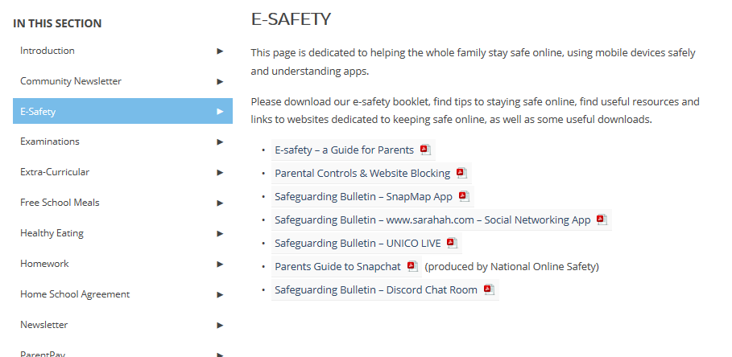

Peer on Peer Abuse

Cyber bullying: While the emotional aspects of bullying continue to be devastating, the internet and social media have changed the way children experience bullying. Cyberbullying, simply put is bullying that happens online through social, gaming or instant messaging platforms.

A core value of Kings Norton Girls’ is Respect, so if we respect all by not posting or making upsetting comments online we can all have positive wellbeing during this prolonged time at home.

To help you support your child on this I recommend the following website which includes practical ways to tackle cyberbullying should it happen. I have shown a screen shot example below for 11-13 year old discussions with parents from the site. https://www.internetmatters.org/issues/cyberbullying/

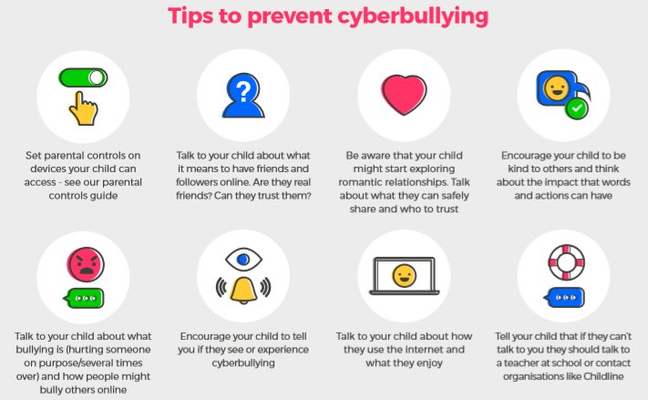

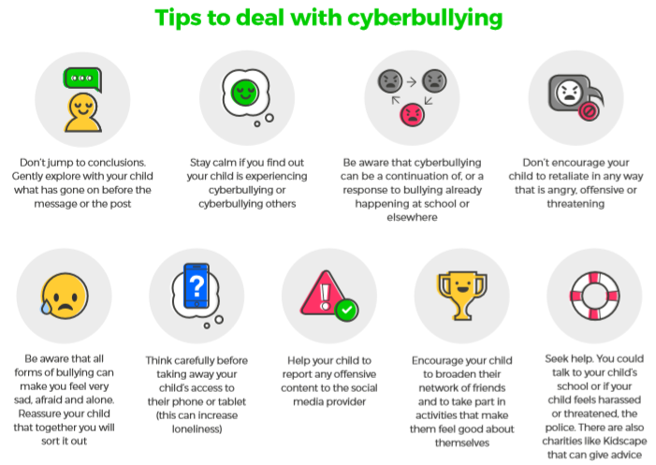

Sexting

The time to talk about sexting with your child is as soon as they start using the internet or get a mobile phone! Remember it’s not just nudes, it’s any image or video that could be deemed as provocative.
Tell them
- It may cause emotional distress
- It could affect your child’s reputation in a negative way
  - Explicit content can spread very quickly over the internet and affect your child’s reputation at school and in their community both now and in the future. It could also affect their education and employment prospects.
- Sexting is illegal

Explain what can happen to an image
- Remind your child that once an image has been sent, there’s no way of getting it back or knowing where it will end up.
- Ask them to think before they send a picture of themselves: ‘would I want my family, teachers or future employers to see it?’
Be prepared
- Talk to your child about having some responses ready if they are asked to send explicit images.
- ChildLine has created a free app which has witty images to send in reply plus advice on how to stay safe.
Tackle peer pressure
- Show you understand how they may feel pushed into sending something even though they know it isn’t the right thing to do.
- Help them to understand that the results of giving in to pressure could be much worse than standing up to it.

Grooming, radicalisation and sexual exploitation

The best way to deal with this risk is to prevent it happening by making sure your child is well-informed, uses privacy settings on social networks and knows that they can talk to you if they feel unsafe or worried.

Teach your children how to stay safe online:
Keep personal information private
- Private details which could identify them in the real world – name, age, gender, phone number, home address, school name, and photographs – should only ever be shared with people they know.
Privacy settings
- Spend time together looking at the privacy settings. It’s always best to assume that default settings are public and should be changed accordingly.
Reviewing apps, site, apps, and games they use
- You will probably use social networks yourself, but you might want to know about new ones that your child is using or wants to use. Use them yourself and set up your own account so you can experience what your child might see.
Know who their friends are
- Talk to them about being cautious about what they share with people online. Remind them that even though people they’ve met online might feel like friends they may not be who they say they are.
Encourage your child to talk to you
- If something makes your child worried or uncomfortable online their best course of action is always to talk to you.
Online support
Online support for parents and carers to keep their children safe online includes:
- Internet matters (www.internetmatters.org)
  - for support for parents and carers to keep their children safe online
- London Grid for Learning (www.lgfl.net/online-safety/)
  - for support for parents and carers to keep their children safe online
- Net-aware (www.net-aware.org.uk)
  - for support for parents and careers from the NSPCC
- Parent info (https://parentinfo.org/)
  - for support for parents and carers to keep their children safe online
- Thinkuknow (www.thinkuknow.co.uk/)
  - for advice from the National Crime Agency to stay safe online
- UK Safer Internet Centre (www.saferinternet.org.uk/advice-centre/parents-and-carers)
  - advice for parents and carers

KNGS staff will endeavour to make contact with our parents/students every two weeks or so.
These communications will be used to reinforce the importance of children being safe online.

Section 3: A selection of other support services available
Support services for specific issues

Medical Advice
- If you require support or advice from the NHS, but it is not an emergency
  - Call 111.

Police
- If you require police advice or to report crimes, but it is not an emergency
  - Call 101

Young Carers
- Young Carers
  - www.spurgeonsyc.org/birmingham/
  - 0121 6380876

Drugs/Alcohol
- Aquarius
  - www.aquarius.org.uk
  - 0121 622 7780

Food/Eating Issues
- Beat: Under 18s helpline, webchat and online support groups for people with eating disorders, such as anorexia and bulimia.
  - 0808 801 0677

Domestic Abuse
- Birmingham and Solihull Women’s Aid
  - Helpline 0808 800 0028

Mental Health

Emotional difficulties
- Young Minds Parents Helpline: 9:30-16:00 (Monday to Friday) – Free and confidential support, information and advice for any adult worried about the emotional problems, behaviour or mental health of a child/young person. Call 0808 802 5544.

Suicide
- HOPELINEUK: If you are having thoughts of suicide or are concerned for a child or young person that might be, you can contact this service for confidential support and practical advice. 10:00-22:00 (weekdays), 14:00-22:00 (weekends and bank holidays). More information can be found at
  - www.papyrus-uk.org.
  - Call 0800 068 4141,
  - Text 07786209697
  - email pat@papyrus-uk.org

Bereavement
- Grief Encounter: This service offers a flexible and accessible service which aims to professionally care and respond to bereaved children, young people and their families via counselling and interactive online services.
  - www.griefencounter.org.uk.
  - Call 0808 802 0111 (free to call, Monday-Friday 9:00-21:00)
  - email grieftalk@griefencounter.org.uk
Section 4: The law on leaving your child on their own

The law doesn’t say an age when you can leave a child on their own, but it’s an offence to leave a child alone if it places them at risk.

Use your judgement on how mature your child is before you decide to leave them alone, e.g. at home or in a car.

The National Society for the Prevention of Cruelty to Children (NSPCC) says:
children under 12 are rarely mature enough to be left alone for a long period of time and children under 16 shouldn’t be left alone overnight, babies, toddlers and very young children should never be left alone

Parents can be prosecuted if they leave a child unsupervised ‘in a manner likely to cause unnecessary suffering or injury to health’.

Section 5: Well-being

Advice on keeping good mental health: https://www.nhs.uk/oneyou/every-mind-matters/coronavirus-covid-19-staying-at-home-tips/

Government advice on supporting children and young people’s mental health and wellbeing: https://www.gov.uk/government/publications/covid-19-guidance-on-supporting-children-and-young-peoples-mental-health-and-wellbeing?utm_source=198a9e75-a418-4442-9102-7c714bd37c3c&utm_medium=email&utm_campaign=govuk-notifications&utm_content=immediate

Advice on keeping your body fit: https://www.nhs.uk/oneyou/for-your-body/

