A Level Studies Taster Session

Provide detailed answers to the following questions?
What is ‘the media’?

What is Media Studies?

Look up the following terms and provide definitions:-
Sign
Signified
Encoded
Code
Denotation
Connotation
Decode

Task 2: Read the Semiotics, The Basics handout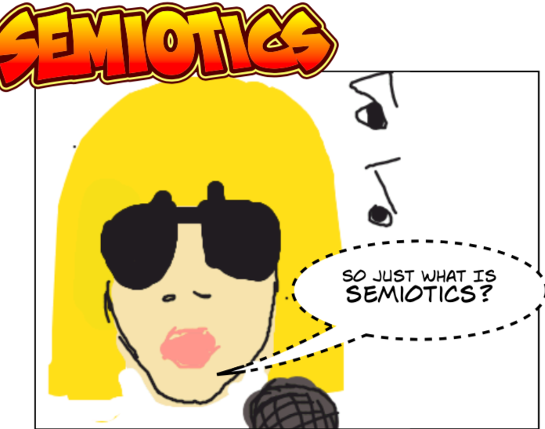
Task 3: Go through the Media Language PowerPoint and complete the tasks in it.

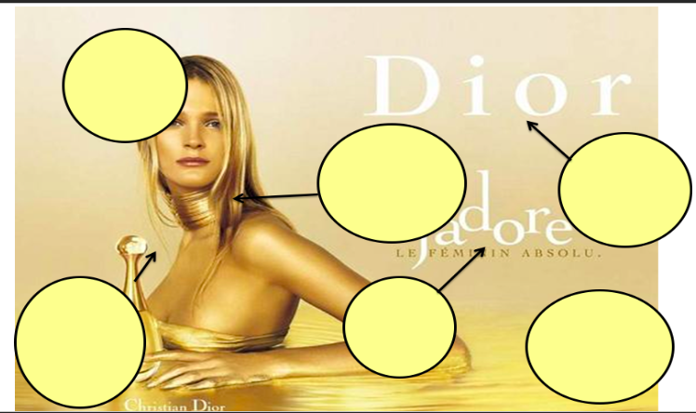
Task 4: Complete the annotation of this Dior Ad

Task 5: Using the terms from today’s session write a paragraph of your analysis of the Dior advert.

